***AURA TRENDING METAL WATCH:***

***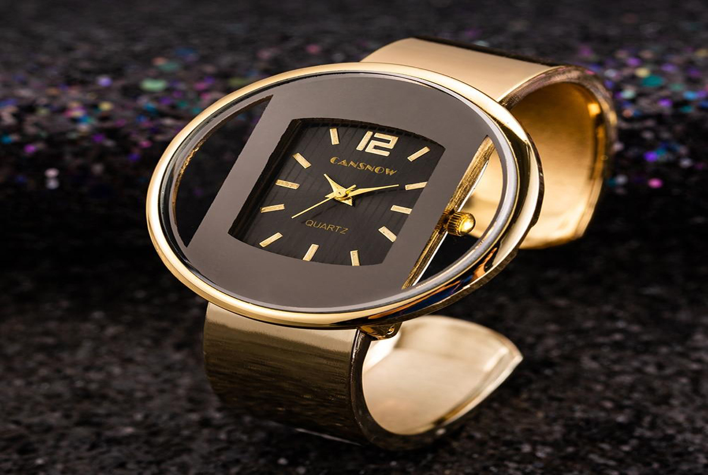  
DETAILS ABOUT THIS WATCH:***

MOVEMENT Quartz  
CASE SIZE 34 mm  
CASE MATERIAL Stainless Steel, Wood  
CASE SHAPE Round  
CASE THICKNESS 7 mm

***SPACES***

**CASE SIZE:**34mm

**CASE SHAPE:**Round

**CASE MATERIAL:**Stainless Steel

**CASE THICKNESS:**6mm

**CRYSTAL TYPE:**Mineral

**Price**

**Rs:2,400**